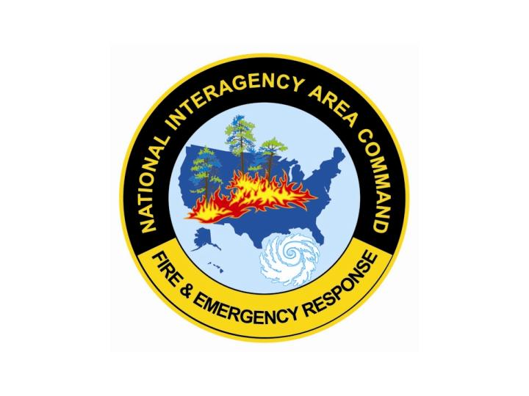

Delegation of Authority

To: (name), Area Commander

From: Agency Administrator, Unit

You have been assigned as the Area Commander for large fires on the AAA National Forest effective xxx hours on month day, 201x.

You have full authority and responsibility for the management and coordination of following incidents and the IMTs managing them -

Your Area Command Team will work within all legal statues and current policy of the agencies and broad direction given by the Agency Administrators signatory to this delegation.

Signature(s) ___________________ Date ___________
(name)
(unit)

Accepted:

_______________________ Date ____________
(name)
Area Commander

